XCGⅡ Roller dry magnetic separator

Instructions product instruction

1.Main use of product: The XCG Ⅱ120 roller dry magnetic separator is mainly used for dry separation of magnetic minerals and strong magnetic minerals. It is widely used in scientific research institutes, universities, mining enterprises and laboratories.
2. Main technical parameters of the equipment:
1. Roller size: diameter φ120mm width (double working face) 30+30mm
2. Maximum magnetic field strength: 14000 Gs In general use can be adjusted in the range of 600-14000 Gs (related to material characteristics).
3. Magnetic pole distance adjustment range: 4-8mm
4. Sample size range: (magnetic pole distance) 0-5mm Generally applicable size: ~ 1.0-3.0mm
5. Magnetic field adjustment range (for reference, related to material characteristics) : When the magnetic pole distance is 4mm, the strong magnetic field position is 5000-14000 Gs. When the weak magnetic field position is 1600-5000 Gs, the strong magnetic field position is 4000-12000 Gs, the weak magnetic field position is 1000-4000 Gs, the distance is 8mm Strong magnetic field position 3000-10000 Gs Weak magnetic field position 600-3000 Gs
6. Reference productivity: 5-25 kg/h
7. Roller speed: 55 r/min
8. Electric vibration feeder: frequency adjustable.
9. Power supply: 220V50Hz. The device body is properly grounded.
10. Power consumption of the whole machine: not more than 500VA. 11. Overall dimensions: length × width × height (360×450×460 mm) 12. Reference weight: ~ 75 kg
3. The machine is mainly composed of (01) excitation system, (02) rotating mechanism, (08) feeding system, (07) product collection part and (03) electric control system.
1. Excitation system: composed of fixed magnetic pole, roller speed magnetic pole and excitation winding and excitation DC power supply installed on both, the upper and lower magnetic poles are arranged in parallel. The closed magnetic loop is formed by two rolls with a diameter of 120mm and the lower flat magnetic pole. The two maximum working distances can be adjusted by increasing or decreasing the backing plate. By adjusting the voltage of the voltage regulator, the DC current supplied by the silicon element to the fixed excitation group and the rotating magnetic pole excitation winding supplied by the brush can be smoothly increased from zero to the amount to the rated value 2 According to the rate, in order to adapt to the selection of different minerals, the magnetic field strength range of the machine can be divided into strong magnetic field and weak magnetic field, which is selected by the magnetic field selection switch on the panel. When the separation magnetic distance is 4mm, the magnetic field selection switch is set to the "strong magnetic field" position, and the excitation current is 2 amps, the maximum magnetic field intensity is not less than 14000 ost. (1110KA/m)
Main structure diagram

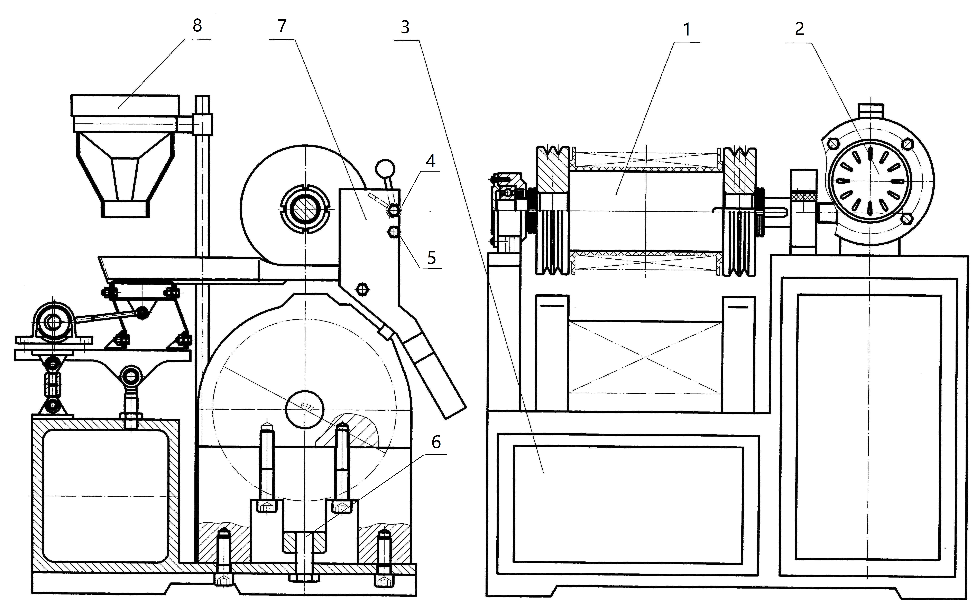
01. Rotating magnetic roller (fixed magnetic roller)
02. Dynamic roller motor 03. Electric control part
04. Heavy hammer cleaning 06. Clearance adjustment bolt 07. Discharge chute
2. Rotating mechanism: The micro motor is decelerated by the reducer to rotate the roller magnetic pole. The rotational speed of the rotating magnetic pole is approximately 55 r/min.
3. Feeding system: The feeding system consists of a feeding hopper, a reciprocating vibrating feeder, and a feeding cone. The reciprocating feeder can be adjusted and controlled by a micro vibration motor to regulate the frequency of the electromagnetic feeder to meet the needs of different mineral particles. To adjust the feeding speed, different sizes of feeding bags can be selected for the feeding cone.
4. Product cleaning and collection part: It is composed of a product discharge chute, a heavy hammer cleaning brush, and a mineral container. When the magnetic field is established, the minerals discharged from the chute are non-magnetic (or weakly magnetic minerals). After the magnetic products are attracted to the roller, stop feeding, replace the receiving container, stop the magnetic field charging, and the magnetic materials discharged through the chute into the receiving container are magnetic materials.
5. Electrical control system: It controls the rotation of the roller, the strength of the magnetic field, and the operation of the reciprocating feeder. Working mode: This machine is composed of an excitation system, a transmission structure, a feeding system, and a product cleaning and collection part. The product cleaning and collection part consists of a product discharge chute, a heavy hammer cleaning brush, and a receiving container. When the equipment generates a magnetic field, the received materials are non-magnetic (or weakly magnetic minerals) and are placed in a receiving container. After a certain amount of magnetic products are attracted to the roller, stop feeding, replace the receiving container, stop the magnetic field charging, and the magnetic materials discharged through the chute into the receiving container are magnetic materials and should be placed in another mineral container.
4. Installation, operation and maintenance of the equipment
4.1 Installation: After opening the box, place the machine on a general workbench. First, clean the packaging grease, check whether the fasteners and welding points of the electrical components are loose or fallen off during transportation, and whether the moving parts and instrument pointers are flexible. Connect the power supply and ground wire, test run the machine to make the roller rotate in the direction of the feeding mineral particles. After observing that all parts are normal, it can be used. The magnetic pole spacing of this machine is generally adjusted to 4mm when it leaves the factory.
4.2 Operation: Before starting the machine, according to the magnetic requirements of the selected mineral, choose the appropriate working gap and adjust the magnetic field selection switch to the required position.
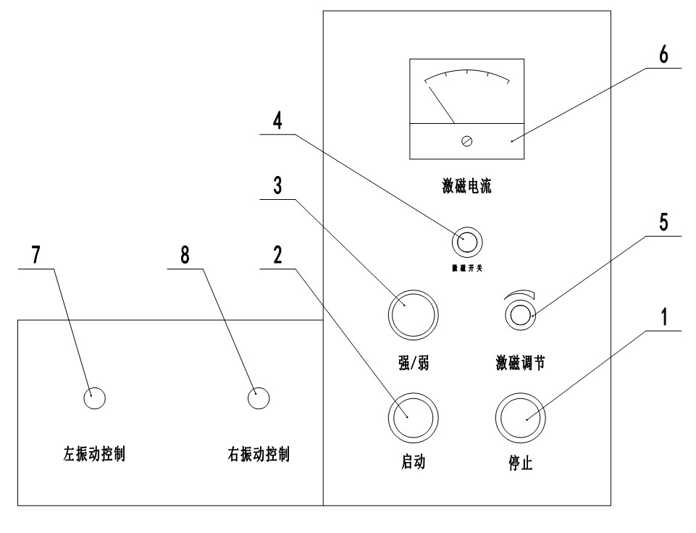
4.2.2 After the power is connected, the power indicator light (1) will light up. Press the start button (2), and the motor will drive the magnetic roller to rotate in the specified direction (when the control part is on the left and the discharge part is on the right, the magnetic roller rotates clockwise), and the magnetic poles will rotate. 4.2.3 Turn the control switch of the ore feeder on the panel (7, 8) to adjust the feeding frequency according to the nature of the ore and the requirements of the ore particles, and select the appropriate reciprocating feeding intensity.
4.2.4 Before starting the machine and connecting the power, turn the voltage potentiometer (5) for adjusting the excitation current to zero. Only after the excitation switch (4) is turned on will the excitation power supply be connected. Gradually increase the excitation current of the excitation winding (6) in a clockwise direction until the required magnetic field strength is reached, depending on the magnetic properties of the minerals to be separated. The excitation magnetic field strength can be pre-selected in the off state: strong or weak. To prevent strong impact current caused by switching under power, which may damage the equipment, the magnetic field strength conversion switch is located inside the control panel of the machine. Generally, the conversion switch is set at the strong magnetic field position (commonly used condition) when the machine leaves the factory. The indicator light (3) will not light up when the conversion switch is in the weak magnetic position, and the indicator light (3) will light up when the excitation is in the weak magnetic section.
4.2.5 Place the ore discharge chute properly and tighten the screws on one side to fix it.
4.2.6 Keep the heavy hammer cleaner (04) in the open state and place the ore receiving container under the product ore discharge chute.
4.2.7 Adjust the height of the ore feeding hopper according to the size of the ore particles, and feed the ore into the ore feeding hopper to start the ore separation. During the operation, pay attention to calibrating the excitation current (6) at any time and keep the ore feeding continuous and uniform. If it is necessary to stop the ore feeding in the middle, rotate the ore feeding switch (7, 8) to reduce or stop the ore feeding.
4.2.8 After the separation is completed, clean the ore feeding hopper, cone, baffle, and ore feeding trough, and pass all the ore through the magnetic field. First, clean the non-magnetic product chute and remove the product, then reduce the excitation current to zero, turn off the power switch, and the roller and ore feeder will stop working. Clean the roller heavy hammer brush and the ore discharge chute, and the experiment is completed.
4.3 Maintenance
4.3.1 Before use, check the moving parts, instruments, and electrical components of the equipment. The equipment can be used only when it is in a normal state. The excitation current is generally 2 amperes and can work continuously for 2 hours. The excitation current should not exceed 2 amperes in general.
4.3.2 Check and add lubricating oil to the motor and gearbox once a year.
4.3.3 During the operation of the equipment, if a fault occurs, stop immediately for inspection and repair. Pay attention to the temperature rise of the excitation winding not exceeding the rated value. If the fuse blows, check for short circuits before replacing it. Do not use fuses of incorrect specifications or directly connect with copper wire or iron wire.
4.3.4 After each batch of experiments, disconnect the power, turn the electromagnetic vibration ore feeder control knob to the minimum position, clean the equipment and workbench, and cover the equipment for the next use.
4.3.5 To facilitate the measurement of the magnetic field strength of this machine, a DC gaussmeter can be configured to assist in the experimental work.
Product inspection sheet
No | XCGⅡRoller dry magnetic separator | Requirement
1 | The magnetic field strength (Oster) reached the specified adjustment range | 0～14000
2 | After one hour of idling operation, the temperature of each bearing is stable | temperature≤70℃
3 | Feed ore and sorting ore work normally
4 | The machinery works normally
5 | The fasteners are securely fastened
6 | The appearance is smooth, and the paint does not leak and fall off
Product packing list
No | Name | Size | Unit | QTY | Note
1 | Roller dry magnetic separator | host | set | 1
2 | Main engine feed control |  | set | 1 | This parameter is configured on a host
3 | charging chute |  | pc | 4
4 | Books |  | pc | 1
5 | inspection sheet |  | pc | 1
6 | Packing list |  | pc | 1
7 | manufacturer certificate |  | pc | 1

